**Task 1**

**Query 1:**

The first query shows the daily trend of complaint for all customer satisfaction levels. This query helps the head of departments in the company to make key decisions to monitor the growth rate of each satisfaction level so that actions can be taken faster whenever there is a spike in negative review. The query utilizes the QueryHandleFact table joined to DateTimeDim table to show results.

**Query 2:**

The second query explains and explore the representatives and departments that handled the most complaints and the satisfaction level of customers after complaints were handled. The output of this query can be used for by the company to evaluate the performance of departments and representatives. Key decision makers in the company can also use information gotten from this query to decisions that will improve the customer support process of the company by identifying its most productive and least departments. The query joins the RepresentativeDim table and the DepartmentDim table to show results.

**Query 3:**

This query shows and explains the number of issues (Question topic) customers are asking and the severity of the questions. The output of this query will help management and company stakeholders in resource allocation when trying to find a lasting solution to customer issues. This query helps to improve customer support and the knowledge base of the company while showing the question topic with the highest count and severity will take center stage. The query takes information from the QueryFact Table and QuestionDim.

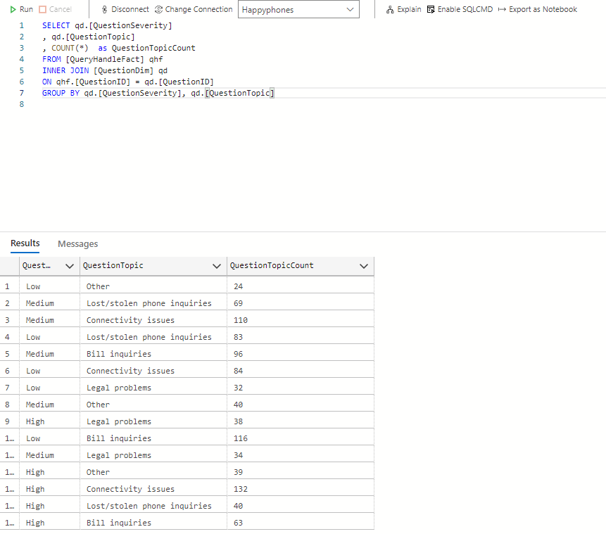

**Task 2**

The dimension tables added for insights are the **TechnicianDim** and the **InactiveUsersDim** tables. Each of these tables provide insights that are presently not available in the schema and help to improve the use of the knowledge base and customer support in the data warehouse.

**1.)** The first-dimension table, **TechnicianDim** table helps to provide information about the technicians sent by HappyPhones LTD to deal with queries lodged by customers. The major type of issues the technicians are sent to deal with are related to “connectivity issues” where physical help of an expert might be needed to resolve the customer concerns and queries.

This table is needed as it helps the company to investigate how issues are being resolved by the technicians sent by the company to the customers and if the customers are usually satisfied by the help offered by them.

Why this dimension?

**TechnicianDim** table was chosen because it can show the TechnicianID (PK), the time it took to attend to a complaint made by a customer, the type of query the technician attends to, the number of hours taken to fix an issue and the customer satisfaction level per technician that attends to them. This provides an extra insight into the schema and shows how the company ensures customer issues are addressed.

How can we use this dimension?

Insights gotten from this table can help the company find out to improve on their company-to-customer relationship, identify the most effective technicians and devise ways to improve overall customer satisfaction.

**TechnicianDim** table effortlessly blends with the QuestionDim table of the schema using the QuestionID as a foreign key.

**2.)** The second-dimension table, **InactiveUsersDim** helps to provide information about customers that have decided to terminate their mobile plan subscription with the company. This table is needed to show why customers might choose to end their subscription with **HappyPhones LTD** and why such customers choose to do this.

Why this dimension table?

**InactiveUsersDim** table can show the InactiveUserID (PK) as the unique identifier of customers that choose to end their subscription, MobilePlanID (Fk) as the mobile plan the customer was on before unsubscribing, the number of complaints made by the customer before choosing to become inactive. This dimension table was chosen as it allows the company to understand the customer support system and identify problems.

How can we use this dimension table?

Insights gotten from this table can help the company understand the reasons why any loss of customers could arise and how to tackle these reasons, improve customer retention and reduce the number of complaints made by the customers.

**InactiveUsersDim** seamlessly integrates into the customers, mobile plan and question tables using the CustomerID, MobilePlanID and QuestionID as foreign keys.

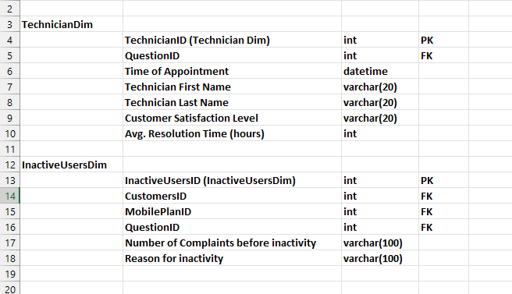

**Task 3**

**REPORT ON HAPPYPHONES LTD DASHBOARD**

The HappyPhones Ltd dashboard was created to help the company tackle the problem of identifying customer support issues and how company representatives have been effective in resolving queries while improving knowledge base management. Each of the charts in the dashboard work towards giving the decision makers of the company a clear overview of the most common customer complaints and issues as well as understanding the performance of the company’s departments over the period of ten years.

Who are the audience this dashboard was created to communicate to? Who is going to make decisions with the insights gotten from this dashboard? All these factors and questions were put into mind and well accounted for during the process of creating this dashboard.

The **summary cards** in the dashboard were inserted to show a quick understanding of the **average length of calls made by customers** and the **total number of customers** in the company. The **line chart** also showed the **amount that has been spent on resolving queries over the period of ten years** while the **bar chart** identifies the **satisfaction levels of customers in the company after lodging a query**. The **representative detail table** clearly identifies the knowledge base of the company by showing **information about the representatives and their performances**. The **city and year filter** allows the key decision makers **evaluate the dashboard based on conditions** they would like to see.

The dashboard aesthetics was chosen to reflect a neat and ordered design layout. Color usage was used minimally to ensure that the audience focus on the main information that the dashboard is trying to pass. Spacing was prioritized to avoid decluttering and the most effective visualizations and charts were utilized. To improve aesthetics, icons that visualize the summary cards were also added. The addition of filters to the dashboard also greatly improved its interactivity.

Overall, the visualizations blend to give the audience a general overview of the customer support process and knowledgebase of the company by showing the company representatives and departments and how they have performed, the general satisfaction feeling from their customers and the amount the company has spent to resolve issues. This dashboard suggests enough insights to make business decisions that will improve the overall efficiency and effectiveness of the company in the long run.

**Task 4**

**Q1:**

**What risks do businesspeople face with respect to expertise and experience while introducing new BI technologies and analytical techniques?**

a. Organizations will not have the expertise in the new concepts and techniques to

effectively use the new tools

**Q2:**

**When defining data quality requirements, you should keep in mind that:**

b. Data quality problems are often caused by conflicting data silos

**Q3:**

**When designing a BI application, what is more important?**

c. Consistent templates

**Q4:**

**Which of the following is true?**

a. Once created, the data marts will keep on being updated from the data warehouse at

periodic times

**Q5:**

**Use storyboards to:**

b. Determine how the businessperson will interact with the application

c. Understand how different analyses are related

d. Create the workflow between different analyses

**Q6:**

**What is most important when it comes to data visualization:**

c. Enhancing user understanding